**Grid Configuration using JSON**

1. **hub_config.json :**

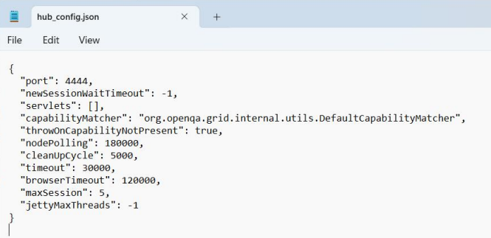

**java -jar selenium-server-4.10.0.jar -role hub -hubConfig hub_config.json**

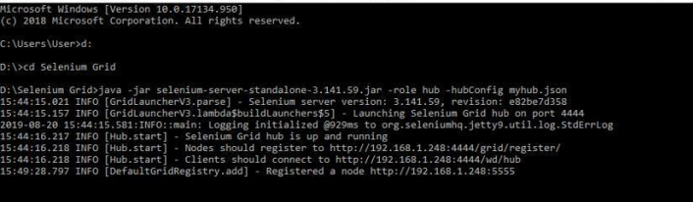

**mynodes.json :**

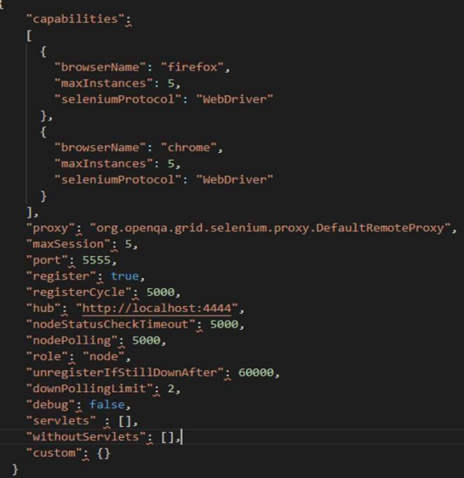

**java -Dwebdriver.gecko.driver="geckodriver.exe" - Dwebdriver.chrome.driver="chromedriver.exe" -jar selenium-server-4.10.0.jar -role node -nodeConfig mynodes.json**

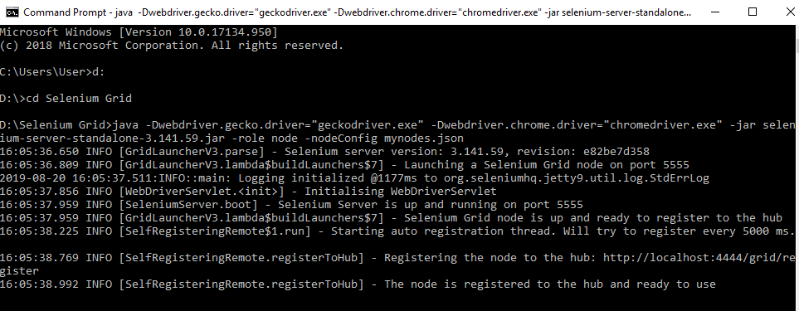

**http://localhost:4444/grid/console**

